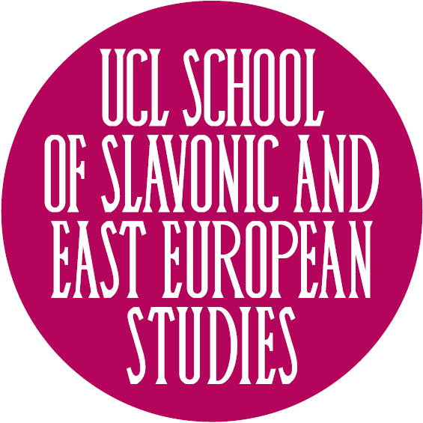

Conference: Historicizing “Whiteness” in Eastern Europe and Russia

Institute for Political Research, Spiru Haret street no 8, Bucharest, zip-code 010175

Tuesday June 25:

9.15-9.30 - Welcome remarks

9.30 – 10.45 Keynote – Anikó Imre (University of Southern California):
Colorblind Nationalisms

10.45-11.00 – coffee break

11.00 – 12.40
Chair/ Discussant: Steffi Marung (University of Leipzig)
Colonialism and Imagining the Self in Eastern Europe

- Monika Bobako (Adam Mickiewicz University) - White Skin, White Masks. Re-reading Frantz Fanon from Eastern European Perspective

- Zoltán Ginelli (Open Society Archives) - Hungarian Indians: Racial and Anti-colonial Solidarity in Post-Trianon Hungary

- Marianna Szczygielska (Max Planck Institute for the History of Science) - Engendering Wildlife and Whiteness: Elephants, Ivory and Zoos (1870s-1940s)

12.45-14.15 - lunch

14.20 – 16.00
Chair/ Discussant: Agnieszka Kościańska (University of Warsaw)
Eastern European Whiteness and the Other: Race, Religion and Gender

- Kristína Čajkovičová (Museum of Romani Culture in Brno) - Shifting to the Gadžo Question: The Role of Racialized Sexuality in the Process of Czechoslovak Collectivity

- Bolaji Balogun (University of Leeds) - Whiteness - A Mechanism that Sustains Polishness

- Cătălin Berescu (Romanian Academy) - White Savior, Black Savior: Pro-Roma Activists in Search of an Identity

16.00-16.15 - Coffee break

16.15-17.35
Chair/ Discussant: Emily Gioielli (Missouri Western State University)
Anti-Semitism and Whiteness in Eastern Europe

- Paul Hanebrink (Rutgers University – New Brunswick) - Anti-Semitism, Islamophobia, and the Anti-Communist Legacy in Contemporary Eastern Europe

- Raul Carstocea (Europa Universität Flensburg) - Ambiguous Whiteness and the Anti-Semitic Imagination: Jews in Eastern Europe between Colonised and Colonisers

20.00: Film Screening Cinema Union (Ion Câmpineanu 22, Bucharest, zip-code 030167): Guardian of the Frontier (intro Catherine Baker)

Wednesday June 26

9.30-11.10
Chair/ Discussant: Monika Bobako (Adam Mickiewicz University)
Eastern European Whiteness in Global Perspective

- Dušan I. Bjelić (University of Maine), Transnational Analysis of Mexico and the Balkans: Racial Formations of Nations
- Catherine Baker (University of Hull), The Yugoslav Wars and Transnational White Nationalist Historical Narratives
- Špela Drnovšek Zorko (University of Warwick) - Re-routing East European Socialism, Historicising Diasporic Whiteness

11.15-11.30 – coffee break

11.30-13.10
Chair/ Discussant: Kristin Roth-Ey (University College of London)
Socialism as Ambivalent Whiteness

- Irina Novikova (University of Latvia) - ‘White Gaze’ in the USSR? – ‘Race’ and Technology in the Soviet Films of the 1920s-1960s (from Lev Kuleshov to Mark Donskoi)

- Zsuzsanna Varga (Central European University) - Hungarians and White Privilege in Africa: The World Hunting Expo of 1971

- James Mark (University of Exeter) - A Revolution of Whiteness? 1989 and the Politics of Race

13.10-14.40 – lunch

14.45-16.25
Chair/ Discussant: Ivan Kalmar (University of Toronto)
Liminality, Post-Socialism, and Eastern European Whiteness

- Bogdan G. Popa (University of Cambridge) - “We Belong to a Great Race, the Dacian Race”: Slavery and the Construction of an Anti-colonial White Race in Romanian Historiography

- Chelsi West Ohueri (University of Texas at Austin) - The Jevg Factor: An Exploration of Whiteness, Blackness, and Racialized Identities in Albania

- Kasia Narkowicz (University of Gloucestershire) - The ‘Muselmanner’ as the Ultimate Other

16.25-16.40 - break

16.40-17.15 – Concluding roundtable

20.00 – Film Screening Cinema Union (Ion Câmpineanu 22, Bucharest, zip-code 030167): Oktyabr and Rostov-Luanda (intro Kristin Roth-Ey)

